Chapter 3, Problem 5.

Obtain v₀ in the circuit of Fig. 3.54.

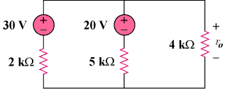

Figure 3.54
For Prob. 3.5.

